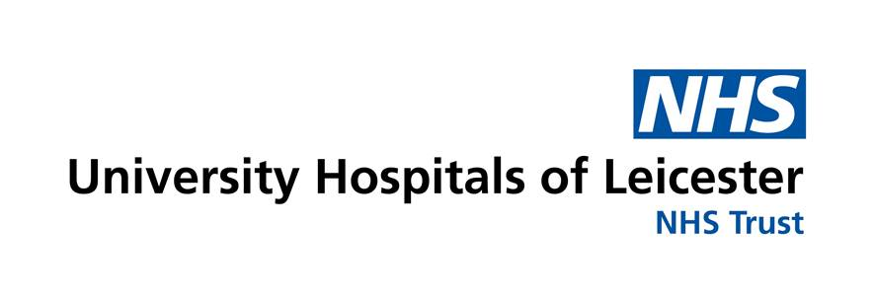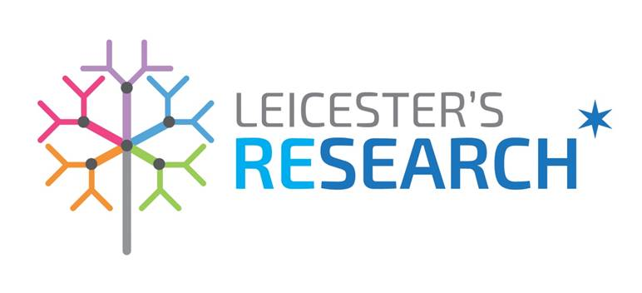

**Appendix 1**

**CONTRACT REVIEW & APPROVAL PROCESS   
– UHL SPONSORED STUDIES**

**When is a contract required?**

There will be some form of contract or agreement required for all research studies sponsored by UHL. The types of contract/s vary depending on the type of study.

UHL R&I department will draw up all contracts where UHL is the Sponsor.

**Types of Contracts/Agreements**

All Chief Investigators must sign the Roles and Responsibilities of Chief Investigator document. This will be requested as part of the Sponsor Review Process.

Most common types of contracts generally drawn up and agreed are:

* Model Agreements for Clinical Trial studies **– mCTA**
* Model Agreement for Non Commercial Research **- mNCA**
* Model Agreement for Clinical investigation with Medical technology **– mCIA**
* Model Agreement for Tripartite Clinical Trial studies – **CRO mCTA**
* Material transfer Agreement **- MTA**
* Collaboration Agreements with Universities
* Site Services Agreement
* Service Level Agreement
* Organisation Information Document (OID) or Statement of Activity
* Miscellaneous agreements such as non- disclosure confidentiality agreement, consultancy, sample testing, interviews etc.

UHL Sponsor informs the Contracts team of the study taking place at UHL.

A copy of the draft contract including costings (if availablemust to be sent to the Contracts team (where appropriate) and all othe rdocuments. Details of costs/supplies will be provided to the participating sites and / or collaborators if applicable.

Negotiate with relevant parties

Appropriate contract/ agreement templates & OID’s will be drafted by the Contracts team and then to be sent to the HRA by either the CI or study project manager

Once contracts have been approved by the HRA or grant organisation the Contracts team commences the signature process and sends the d contracts to the participating sites and/or collaborators.